
ROADRUNNERS INTERNATIONALE MONTHLY HOUSE SIX NEWS AND GOSSIP
(Not to be confused with the Stars and Stripes)
1 August 2007 – 10th Edition

FINAL FLIGHT
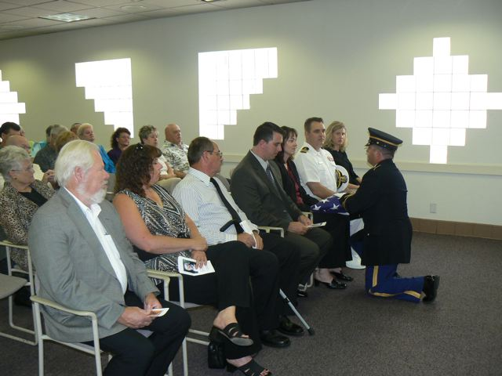
We’re happy to report that no Roadrunners were lost in July. A memorial was held for Tom Bolich on July 28th at the North Las Vegas Air Terminal where Tom was remembered by relatives, his many friends, CIA associates, and fellow Roadrunners. It was standing room only with Roadrunners from several states attending in remembrance of Tom. Members attending were: Frank & Nicki Micalizzi, Sherill & Mary Darlington, Roy Black, Tom & Jean Stanks, Dave Kindell, Flo & Patty DeLuna, Slip Slater, Chet & Joanna Kruleski, Clyde Fancher, Jules Kabat, Harry & Mary Martin, TD & Doris Barnes. The aircraft sounds of the airport, Tom’s son attired in his Navy Commander uniform and the U.S. Army providing military protocol amidst a collection of photos of Roadrunners and Oxcart circa the 1960s provided an atmosphere becoming of Tom’s legacy as a CIA security officer at Area 51 during Project Oxcart. Roadrunner president T.D. Barnes performed the Eulogy.
ROADRUNNER EXHIBIT FUND
Roadrunner Clyde Fancher can be thanked for not only obtaining the North Las Vegas Air Terminal Grand Canyon Room for the Tom Bolich memorial, but also for making the introduction of the Roadrunner officers to the management of the North Las Vegas Air Terminal and the McCarran International Airport serving Las Vegas. He arranged a breakfast where Roadrunners President TD Barnes and Vice President Harry Martin met the Air Port Director where the subject came up of exhibiting Roadrunner historical photos and related items at our local air terminals for public viewing. Creating exhibits for the air terminals are in addition to the exhibit project currently under way for the Atomic Museum and possibly at UNLV. Realizing that construction and reproduction costs for such projects would take away from the funds available for our biennial reunions, the RI staff has created a separate fund for these projects that will be funded by donations. The Tom Bolich family pioneered the funding of this new RI activity by asking donations be made to RI in lieu of flowers at his memorial. Roadrunner Treasurer Jim Prucnal reports the receipt of donations for this cause as a result of the Bolich family’s wishes and the generosity of Tom’s friends. We encourage our members to embrace and continue this worthy cause. For now, checks should be made out to Roadrunners Internationale with a note stating that it is for Tom Bolich Memorial Fund.
REUNION UPDATE:
Reunion Chairman Harry Martin reports the NTS tour has only 3 openings and may be sold out as fees and forms are received the first of this week. Those signed up after the allotted number cutoff will remain on standby in case someone cancels. Please contact Harry prior to sending NTS tour forms and fees from this point on. Unused NTS tour fees will be refunded. Those not taking the tour might consider touring the Atomic Museum instead at the discount rate being offered to Roadrunners by the museum.
NEW MEMBERS & UPGRADES
Roadrunners Internationale welcomes new member Jack Gordon, President of Lockheed Skunk Works and Vice President of Lockheed Martin Corporation, Charles “Dan” Griffin, former YF-12 and brother Donald Griffin, whose father also worked Oxcart and/or the YF-12, Fred L. Adam, former Senior Scientist/engineer Hughes Aircraft Co. YF-12 July Upgrades: John Whittenbury, Donald Borgos, Erik Faraldo, Wayne Pendleton, Lee Kitten, Alva McMillion, Ennio Ripa, Vernon Henderson, Flo Deluna, & Cliff Bush. Life member certificates have been presented to each of members joining or upgrading to permanent membership.
CIA HAPPENINGS
Article 128 is finally on the move and is expected to arrive at Langley around 10 August. One can only imagine the nail biting that’s going on as the A-12 curator and staff try to organize and schedule the dedication of A-12 Article 128 during the September celebration of the agency’s 60th anniversary with the A-12’s future still pending in the U.S. Senate where it’s bill has been attached to a defense spending bill. At this late date it will now be impossible to have the A-12 mounted on its pylons in time for the dedication. At least it will be on site for the dedication provided the infamous National Guardsman from Minnesota doesn’t hijack it somewhere along the way or have his politician friends obtain a stay on its movement. We hope the move is made with security escort because by now he is probably desperate to grab a plane to install “HIS” hoard of stolen A-12 components. There are six things that we Roadrunners should forever remember: 1. The Alamo, 2. Pearl Harbor, 3. The assassination of JFK, 4. The 9/11 attack on America, 5, the vandalism of all our A-12s now on public display to the extent the cockpits can not be shown, and 6, that a former associate member of Roadrunners Internationale is responsible and possesses a vast inventory of the components that he now identifies as his own while our association has nothing but our memories.
The exempli gratia
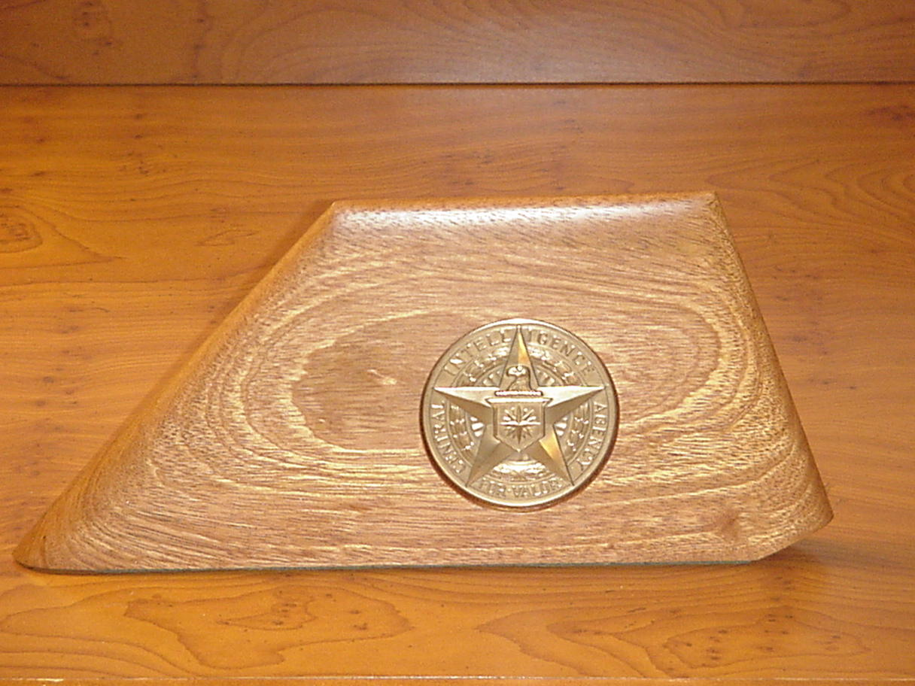
We Roadrunners attending the Blackbird Reunion enjoyed the look of surprise and pleasure when Larry DeCew presented Ken Collins with an A-12 rudder shaped holder for his CIA Intelligence Star for Valor awarded in 1968 for his exemplary performance during Operation Blackshield. DeCew’s honoring Ken in affect honored all Roadrunners.
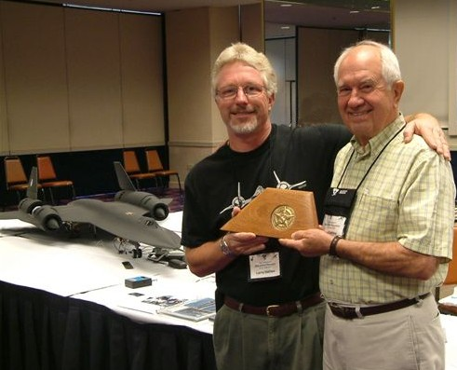


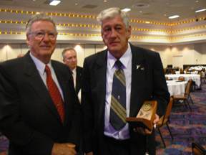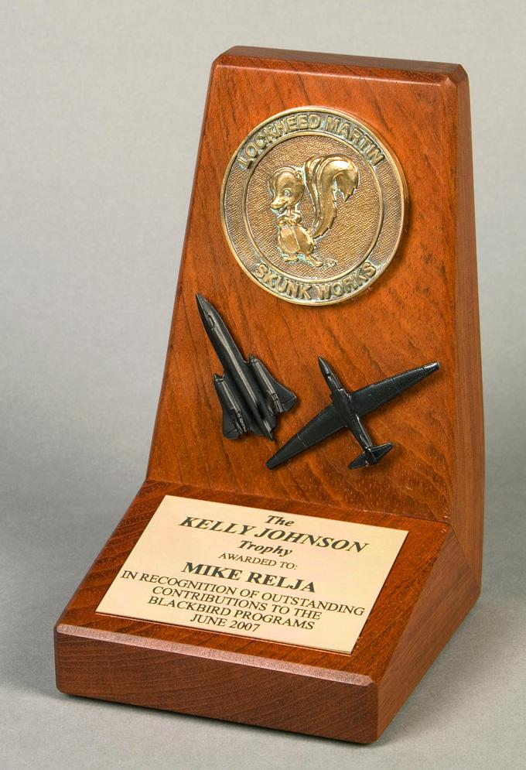
Equally surprised and honored at the Blackbird Reunion was Mike Relja who was awarded the 2007 Kelly Johnson Trophy. Mike, currently with NASA at Dryden, has been very involved with the Roadrunners’ efforts to support the A-12s in retirement. He served in the USAF with the SR-71 Blackbird. Someone needs to nominate Mike to become an associate member of the Roadrunners (or voting member if he qualifies through affiliation with the CIA U-2, A-12, or Air Force YF-12 programs.)
THE AUTHORS’ CORNER
Roadrunner Donn Byrnes has published another excellent book. While it has nothing to do with our Roadrunner activities, we applaud Donn for his continued productivity. Donn has always been a steadfast supporter of our Roadrunner activities. When cornered to provide some stories for the newsletter, Donn replied. “I really don't have any exciting stories to tell about the Area or the program. The majority of my chores associated with the Area
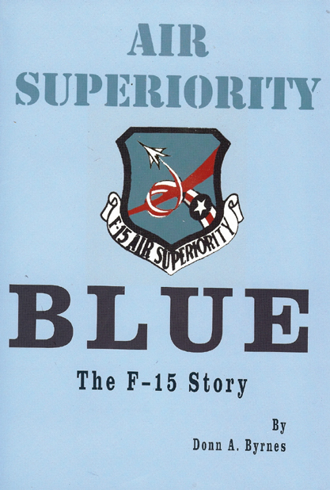
were as U-3 taxi driver. As such I got lots of practice checking in at Mercury and flying north to "the crater" and then east around the mountain to the Area. One of my frequent passengers was an AF Major named Claire Fox. It seemed he always needed to visit Area 51 on Wednesday afternoon (I think it was Wednesdays or was it Thursdays) because the mess hall served steaks on that evening. I'd swear he had his brief case lined with toast so he could take several steaks back with him to EAFB. The only real news about me is that I finally finished my book AIR SUPERIORITY BLUE - The F-15 Story.” Well Donn, that’s an excellent story, except you didn’t tell all that you did. I seem to recall you flying that little ole plane up to some of our X-15 emergency landing sites (which included Groom Lake) where you would land on the dry lake bed and drop a steel ball onto the surface and then measure the indenture to determine how solid the lake bed was for an emergency landing. As I recall that was after Joe Walker tried that with the F-104 where it sunk in the bentonite all the way to the bottom of the fuselage. Talk about someone screwing the pooch!!!! We like to have never got that Starfighter back to Dryden.
ON THE SERIOUS SIDE
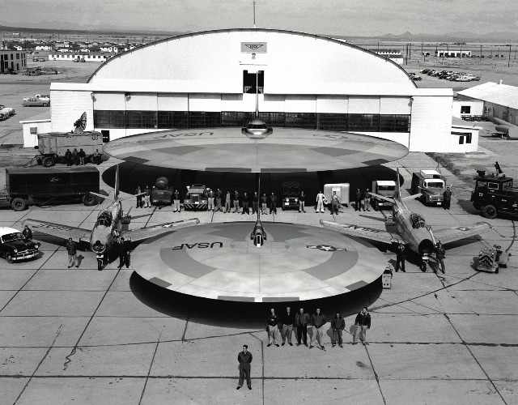
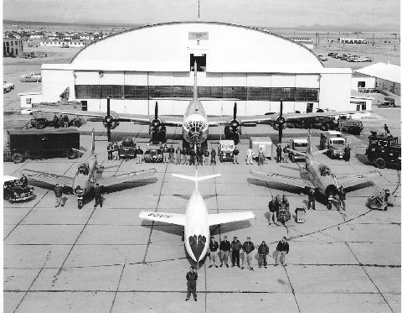
If you will recall last month we published a request from Associate Member Michael Schratt requesting information on the saucer aircraft reportedly at MacDill AFB in 1967. Several of our members responded with basically the same report. A few years ago Michael reportedly visited Edwards AFB with artist concepts of the airplanes supposedly tested in the 1960s. He was basically told why the concepts couldn’t possibly fly. Reportedly, shortly afterward, his web site featured a large collection of doctored NASA photos where a variety of NASA aircraft had been replaced with images of the disk planes. One of the hangars still had the NASA emblem. The circular wing aircraft shown in the lower photograph are models, mockups, or artist renderings inserted into actual photographs using computer software. For example, the (original) photo on the left has been manipulated in the photo on the right with software to insert two “flying saucers” in front of the NACA hangar. The original photograph was taken circa 1955 at Edwards AFB and shows a B-29, two F-86s, and a D558 research aircraft. Standing at the bottom center of the photo is test pilot Scott Crossfield. The computer-manipulated photo is identical except that the B-29 and the D558 have been replaced with saucer shaped aircraft. Once again the Roadrunners have lived up to our motto: “In God We Trust – All Others We Monitor.” Videmus omnia “We See All” Good work, guys!!!
ASSOCIATE MEMBER NEWS
Something is wrong with this picture. First Dennis Sullivan and Ken Collins do China, Russ Buyse does Tahoe, the Overstreet’s do the Rhine River cruise across Germany, and now Alan Johnson has topped everyone while a lot of us are stuck in Las Vegas 24/7. It’s not fair!!!!
Alan and Lorraine’s Big Year
This year we celebrated 30 years of marriage on the 29th January and it was also Lorraine’s 50th Birthday in April so we decided that we would do a bit of traveling.

First up was a vacation taken in January 2007 to Kenya (it was snowing on the day when we got married back in 77) So this day, 30 years later was going to be a bit warmer. HOT! HOT!  This was a two-week beach vacation at the Voyager Beach hotel in Mombassa. While there we took in a two-day safari to the Tsavo East Safari park, which was about 150 km from Mombassa. Plenty of photograph opportunities were taken while on this vacation |  | 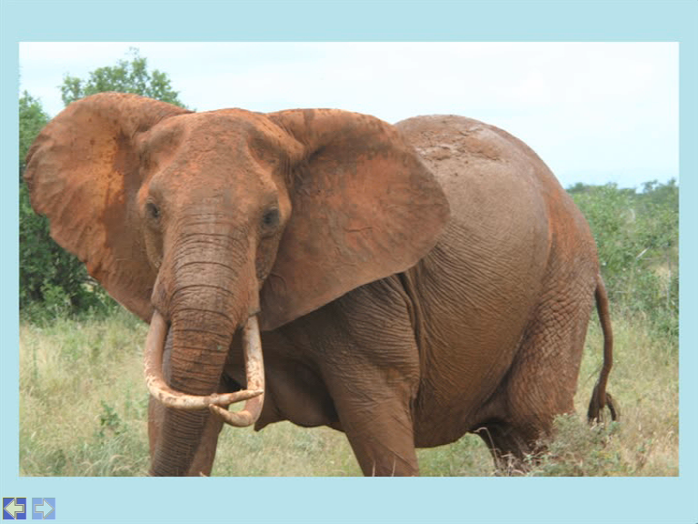
This Bull elephant crossed the road just in front of the mini bus. (Picture taken by me) Only 4 of us plus the driver in the mini bus so plenty of room to move around. Driver was great, took his time so we could have a good look for the animals.
Hotel, Food, Drinks and people great
Excellent Holiday!! Would definitely go back and most probably will.
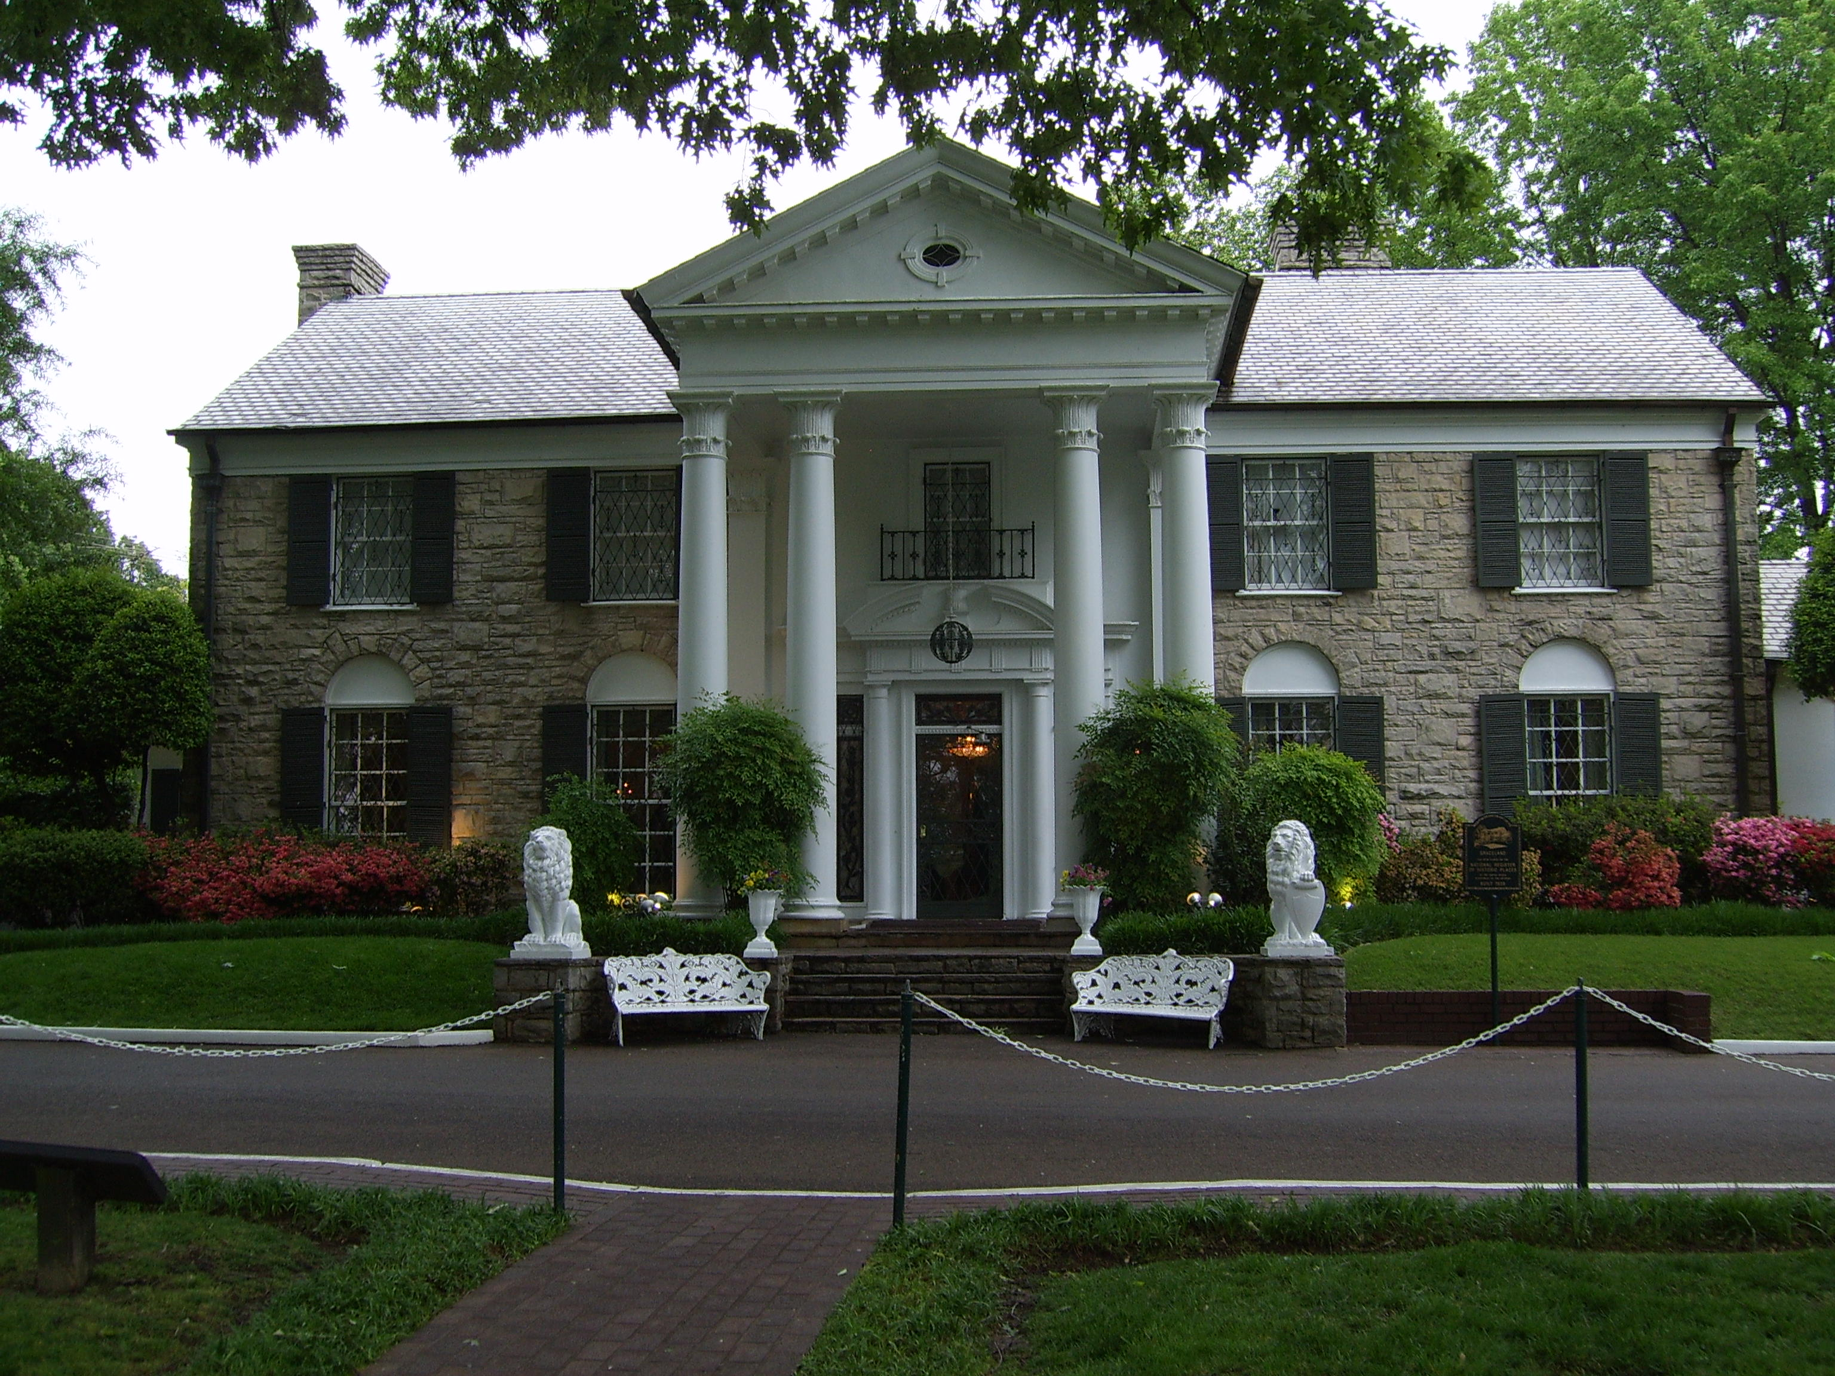 | Next up was Lorraine’s 50th birthday on the 12th April. For this I took Lorraine to Memphis and we stayed at the Heartbreak Hotel. Lorraine has always been an Elvis fan and she enjoyed the trip110%, Went to Graceland’s of course, and did the VIP tour which allowed you to visit the various Elvis museums more than once on the same day. Some very nice cars in the museum and of course two aircraft.  Lorraine came away with a few souvenirs and she is talking about a second visit.
May Bank holiday was a 4-day visit to Stirling in Scotland. We normally spend our wedding anniversary here, but we were away in a warmer climate this year.  Paid a visit to Blair Athol castle. Tasted the Whiskey of course. Love Scotland!! Even though it rained, but then again it always rains in Scotland. | 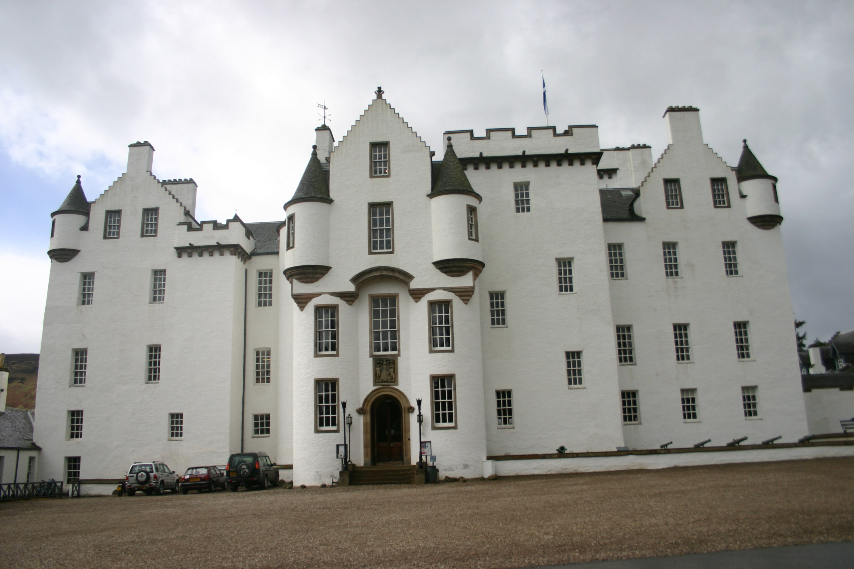
Next. We were intending to go back to the Dominican Republic prior to me going to the Roadrunners Reunion but instead we are both taking 10-day break in Las Vegas.

So all- in- all a GREAT YEAR,
Yep!! We hate you Alan. Expect KP duty during the reunion.
February 2008 SR-71 Symposium at Pima Museum Cancelled
Associate RI member Don Stein reports that after a substantial amount of thought it has been decided to not pursue another SR-71 Blackbird Symposium with the Pima Museum in Tucson next February. The museum and the symposium organizers hope to resume the symposium in the near future. This is disappointing news to many of our Roadrunners who supported and participated in the symposiums and activities that in the past thrilled and inspired kids and had the solid attention of many thousands in telling the Blackbird story. Many of us recall the honor bestowed upon MGen Doug Nelson when he was enshrined in the Arizona Aviation Hall of Fame. Another of our Roadrunners, BGen Ray Haupt was also enshrined in the Arizona Aviation Hall of Fame at Pima prior to General Nelson. In addition it gave the museum a terrific amount of exposure both at the gate and with local politicos. Sadly, this probably also ends the Saturday night parties hosted by the Steins during the symposium festivities. Thank you Don and Mary Kay for the fond memories. We hope there will be more.
THE SPEAKER’S CIRCUIT
None of the Roadrunners on the speaker circuit reported in this month so we’ll give Dick Roussell and the rest of the VooDoo drivers a break and talk about our engineering brothers and sisters. Harry Martin, OB Harnage, Fancher, Solheim, Macalizzi, Darlington, and the rest of the EM had better start bracing themselves, their turn is coming up. Same applies to “The Customer”, CarCo, Reeco, and all you others entities with funny names that I’ve overlooked. Also, in case you don’t know the EG&G gang, Jim Freedman, Davie Haen, Denise Haen, Wayne Pendleton, Jules Kabat, and yours truly TD Barnes aren’t included with what has been written about the Honeywell, Lockheed, Kodak, P&W. EP, Hughes, Magnavox, David Clark, Firewel engineers below. We were different – sort of like Sam Pizzo and the rest of the 1129th navigators!!!! Wayne switched to Lockheed but he remained different. Close call, huh Pendleton?

Understanding Engineers - Take One Two engineering students crossing the campus when one said, "Where did you get such a great bike?" The second engineer replied, "Well, I was walking along yesterday minding my own business when a beautiful woman rode up on this bike. She threw the bike to the ground, took off all her clothes and said, "Take what you want." The first engineer nodded approvingly, "Good choice; the clothes probably wouldn't have fit."
Understanding Engineers - Take Two To the optimist, the glass is half full. To the pessimist, the glass is half empty. To the engineer, the glass is twice as big as it needs to be.
Understanding Engineers - Take Three a pastor, a doctor and an engineer were waiting one morning for a particularly slow group of golfers. The engineer fumed, "What's with these guys? We must have been waiting for 15 minutes!" The doctor chimed in, "I don't know, but I've never seen such ineptitude!" The pastor said, "Hey, here comes the greens keeper. Let's have a word with him." "Hi George! Say, what's with that group ahead of us? They're rather slow, aren't they? The greens keeper replied, "Oh, yes, that's a group of blind fire-fighters. They lost their sight saving our clubhouse from a fire last year, so we always let them play for free anytime." The group was silent for a moment. The pastor said, "That's so sad. I think I will say a special prayer for them tonight." The doctor said, "Good idea. And I'm going to contact my ophthalmologist buddy and see if there's anything he can do for them." The engineer said, "Why can't these guys play at night?"
Understanding Engineers - Take Four What is the difference between Mechanical Engineers and Civil Engineers? Mechanical Engineers build weapons and Civil Engineers build targets.
Understanding Engineers - Take Five The graduate with a Science degree asks, "Why does it work?" The graduate with an Engineering degree asks, "How does it work?" The graduate with an Accounting degree asks, "How much will it cost?" The graduate with an Arts degree asks, "Do you want fries with that?"
Understanding Engineers - Take Six Three engineering students were gathered together discussing the possible designers of the human body. One said, "It was a mechanical engineer." Just look at all the joints." Another said, "No, it was an electrical engineer. The nervous system has many thousands of electrical connections." The last one said, "Actually it was a civil engineer. Who else would run a toxic waste pipeline through a recreational area?"
Understanding Engineers - Take Seven "Normal people believe that if it ain't broke, don't fix it. Engineers believe that if it ain't broke, it doesn't have enough features yet"
Understanding Engineers - Take Eight An architect, an artist and an engineer were discussing whether it was better to spend time with the wife or a mistress. The architect said he enjoyed time with his wife, building a solid foundation for an enduring relationship. The artist said he enjoyed time with his mistress, because the passion and mystery he found there. The engineer said, "I like both." "Both?" "Yeah. If you have a wife and a mistress, they will each assume you are spending time with the other woman, and you can go to the lab and get some work done."
Understanding Engineers - Take Nine An engineer was crossing a road one-day when a frog called out to him and said, "If you kiss me, I'll turn into a beautiful princess." He bent over, picked up the frog and put it in his pocket. The frog spoke up again and said, "If you kiss me and turn me back into a beautiful princess, I will stay with you for one week." The engineer took the frog out of his pocket, smiled at it and returned it to the pocket. The frog then cried out, "If you kiss me and turn me back into a princess, I'll stay with you and do ANYTHING you want." Again the engineer took the frog out, smiled at it and put it back into his pocket. Finally, the frog asked, "What is the matter? I've told you I'm a beautiful princess, and that I'll stay with you for a week and do anything you want. Why won't you kiss me?" The engineer said, "Look, I'm an engineer. I don't have time for a
girlfriend, but a talking frog, now that's cool."
VOODOO SECTION
We intended to let your VooDoo drivers escape this one, but Frank Murray just sent us this joke that simply must be shared with the membership.

A circus owner runs an ad for a lion tamer and two people show up. One is a good looking, older retired F-101 pilot in his sixties and the other is a gorgeous blonde in her mid-twenties.
The circus owner tells them, "I'm not going to sugar coat it. This is one ferocious lion. He ate my last tamer so you guys better be good or you're history. Here's your equipment -- chair, whip and a gun. Who wants to try out first?" The girl says, "I'll go first." She walks past the chair, the whip and the gun and steps right into the lion's cage. The lion starts to snarl and pant and begins to charge her. About half way there, she throws open her coat revealing her beautiful naked body. The lion stops dead in his tracks, sheepishly crawls up to her and starts licking her feet and ankles. He continues to lick and kiss her entire body for several minutes and then rests his head at her feet. The circus owner's jaw is on the floor. He says, "I've never seen a display like that in my life." He then turns to the retired pilot and asks "Can you top that?" The tough old pilot replies, "No problem, just get that damn lion out of the way."

TIRED OF THE SAME FACES EACH EDITION - SEND US SOME STORIES AND GOSSIP.
President  T.D. Barnes | Vice President  Harry Martin | Secretary  Roger Andersen | Treasurer  Jim Prucnal | Historian  Frank Murray

