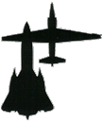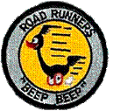
ROADRUNNERS INTERNATIONALE MONTHLY HOUSE SIX NEWS AND GOSSIP
(Not to be confused with the Stars and Stripes)
1 March 2008 – 17th Edition

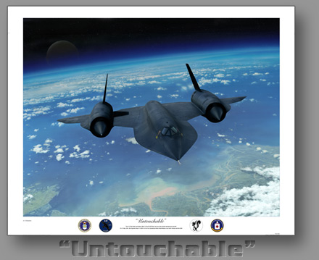
To the Roadrunners who missed out on the CIA’s 60th Anniversary dedication of A-12 Article 128 last September and/or our reunion the following month, we proudly introduce to you Artist Dru Blair who painted “The Untouchable” which honored the A-12 and the Roadrunners at each of these events.
"Untouchable" depicts A-12 #937, piloted by Mel Vojvodich (CIA) passing over Haiphong Bay, North Vietnam on the First Operational Black Shield Mission on 31 May 1967.
Numerous efforts were made by the North Vietnamese to shoot down the A-12, all without success, hence the namesake of this painting: "Untouchable. Included at the bottom of each print are the official seals of the Air Force, CYGNUS, Skunkworks, and CIA. Reproduced on Archival Museum Quality paper stock, each print is individually inspected and signed by the artist. An open edition print signed by the artist only is $65. A special limited edition of 100 signed and numbered artist proofs are individually signed by the 4 surviving A-12 pilots, Frank Murray, Ken Collins, Col Jack Layton, and BGen Dennis Sullivan as well as the artist, Dru Blair, is available for $295. You can visit Dru’s outstanding work at: www.drublair.com.


FINAL FLIGHT
The Roadrunners are happy to report that none of our family deployed on their final flight this past month.
REUNION 2009 UPDATE
Reunion Chairman Harry Martin reports that the basic details of our 2009 reunion are available for review on the Roadrunner web site under Member Activities.

ROADRUNNER OCTOBER 2008 MEXICAN RIVIERA CRUISE
We appreciate the many responses from our members, though most were to let us know they couldn’t make the cruise due to conflicting schedules. It was a relief to know “something to do” is not a concern for our members. This being the case, we have decided to abort the cruise.

"SR-71 Revealed: The Inside Story" (Richard H. Graham)
"SR-71 Blackbird: Stories, Tales and Legends" (Richard H. Graham)
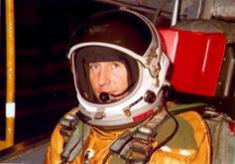
We commend our fellow Roadrunner member Rich Graham for two excellent books written by him, a retired blackbird pilot who went on to head the entire Program. You can view more about Colonel Graham and his books in the Authors section of the Roadrunner web site. His books have it all... technical info, war stories, anecdotes, everything you were looking for. In his second book, he's more of a moderator, introducing 19 other "speakers" and offering background info where appropriate. Col. Graham donates the royalties from his books to the J.T. Vida Memorial fund at the National Air & Space Museum for the preservation of their SR-71.

WINING AND DINING WITH THE VININGS
The Vining hooch at Naples, FL. was ringing with fun and war stores this past month. We understand Bill Fox did an excellent presentation on the A-12 and Don did a great job of duplicating the excellent dining to which we were accustomed at Area 51. We can’t wait for the juicy stories to start leaking out. Jim Anderson on the front roll certainly looks guilty of something. Photos have been posted on the web site under Photo Archives. Direct link: http://roadrunnersinternationale.com/vining2008.html
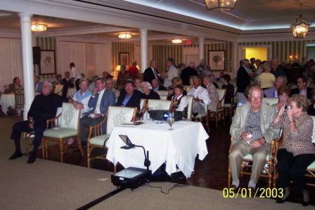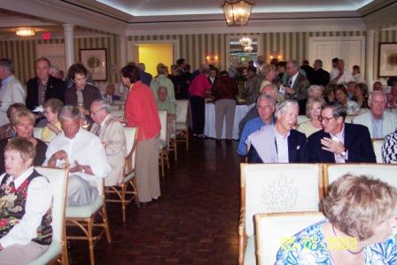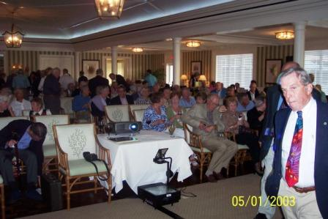

EAA STORE
Most of you should have received the application form and instructions to register at the CIA EAA store. Applications will be available to all listed on the Roadrunners Internationale membership roster. The link below provides a preview of what the Agency store has to offer. Contact the RI officers if you need assistance in registering.
http://66.92.168.126:9126/EAAX_Site/WebPagesUS/home.htm

ROADRUNNER PAMPHLETS
During recent months various members have donated to our Roadrunner exhibit fund. You’ve seen some of the early results where the museum in Mobile has copied some of our exhibit material to create their own Roadrunner storyline to exhibit with the A-12. Most of you have seen the trifold pamphlet recently designed by Ken Collins, Frank Murray and TD Barnes with editing from others of the RI officer staff. This pamphlet is something that we hope will become a standard publication at museums and events to tell the legacy of the Roadrunners, Project Oxcart and Operation Black Shield. The pamphlet has been made available to all who want a copy to print for their personal uses. While the various museums have indicated they will print their own supply for handout, we hope to have a supply of the pamphlets printed up for use at both private and group functions relating to the Roadrunners and their legacy. Since our notice to you by e-mail, we have located printing services who will print and fold the pamphlets for about $.30 each. If you know of anyone wishing to donate to support our mission, we will be most happy to accept and somehow acknowledge such a donation. Thus far RI members Joerg Arnu, TD Barnes, Ken Collins, and Frank Murray have each donated $100 to the project.

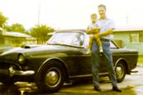
RECALLING SAM NAVE?
Last month we ran an article about the family of Sam Paul Nave seeking information about Sam, who died in 1989 at age 54 when he accidently fell into a creek bed of rocks in front of his home north of S. F. Thanks to the responses of Roadrunners Burgeson, military A-12 pilot assigned to the Operations Evaluation and Test Division at Area 51, and Lee Kitten of Lockheed fame, the family now knows that Sam was a talented and highly respected Flight Engineer on A-12 trainer, Article #124 at Area 51. Burgie reports that Sam was good friend who loaned him the use of his Sunbeam Tiger which he left parked in the employee parking lot near the Skunk works. The photo of the Sunbeam depicts Sam’s brother Ray, and nephew, Eric in 1970. Sam did not fly the blackbird. He was the flight engineer on the A-12 trainer supervising a maintenance crew of Lockheed and contractor personnel to keep the aircraft ready to fly and make repairs when needed.
A-12 MEMORIES by Robert Rodert
• Lou Schalk barrel rolling the Titanium Goose (A-12 trainer) in front of a viewing stand of dignitaries and Kelly of course. Kelly went ballistic because there was a risk of trashing the SAS gyros which weren't built for 360 deg (roll) maneuvers

• Bill Park dead sticking the prototype A-12 from Mach 3 cruise with dual unstarts, many attempted relights as ground support talked to him via his emergency battery radio, counting down to punch out time and finally a single engine relight and landing. Lou and Bill definitely had brass ones!

• Another high pucker factor flight where Lou’s suit cooling air failed. We don't know how hot it got but we’ll never forget the look on his face when they took his helmet off - about half cooked!

• And then there was the time Bill Park punched out on short final as the A-12 went into an un-commanded slow roll that he couldn't counter. At a very low altitude (short final) he ran out of stick throw (hard over) and punched out as the bird went through about 90 deg. roll. His chute swung only once before he was on the ground!

ANOTHER REQUEST FOR IDENTIFICATION (Are they real or impostors?)
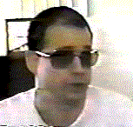
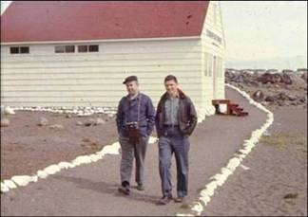
This request is focused mostly towards our former security personnel at the Area who stayed on after Project Oxcart. We’ve been asked to identify the venue of the photo, which was reportedly taken at Area 51, and information about USAF Maj. Tom Mack, Paul McGovern, USAF Capt. Robert Collins, and Dr. Dan C. Burisch as relates to Groom Lake, and Gene Lakes who represents being head of security at the Area. Tom Mack, a retired AF Major, reportedly served in the Air Force from 1972 to 1994. Pictured in the photo above are Tom Mack and Paul McGovern reportedly taken at Area 51 by the son of one of those pictured. (Note the camera ?????? and housing) The photo to the left is Dr. Dan C. Burisch. We will withhold further comment until after receipt of input as to identity or disputed identity and/or representation.

*****
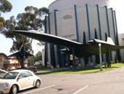
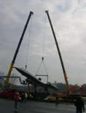
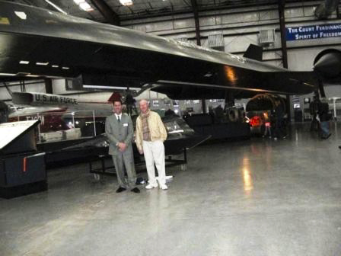
Last month our A-12 fix was the photos of great job done by the USS Alabama Battleship Memorial Park Museum in Mobile. For this month’s A-12 fix, it doesn’t get much prettier and more majestic than Article 130 in retirement at the Aerospace Museum in San Diego. We’re anxious to see the “finished” photo of Article 128 at CIA (left photo). Hopefully that will be the A-12 fix next month. Another museum deserving high marks this month is the Pima Air & Space Museum and Executive Director, Dan Ryan of the Arizona Aerospace Foundation who devoted half a day showing Dennis and Rose Marie Sullivan what Murray, Andersen, and Barnes have been raving about from their recent visit to the museum. Though the museum hosts a SR-71 instead of our favorite, the A-12, it does recognize the A-12’s role in developing the SR-71 and does honor some of the Roadrunners in its Arizona Aviation Hall of Fame.
REMEMBERING THE A-12 UNSTARTS By Frank Murray
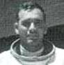
Most of the time the A-12 was a pure joy to fly, whether if was in a pattern back home or on an overflight over the denied territory of an adversary country. In retrospect, an “unstart” was most likely in the region where the duct was most efficient, the duct pressure at its highest, spike positioning most critical. For these reasons the pilot was acutely aware of too “smooth” duct sensations. A bit of rumble was tolerated to avert the unstart. The inlet control system was improved over time and “unstarts” became more of a rare event than matter of fact. The experiences of the A-12 pilots led to much better inlet control systems in the SR-71 aircraft that followed.

THE ENGINE INLET… A very big part of the A-12 design was the air inlet system. This system had to accommodate the needs of the J-58 turbo-ramjet engine, from subsonic speeds to more than Mach 3 at altitudes from sea-level to 90,000 feet. This was quite a task that Lockheed took on and made to work. The main parts of the inlet included the nacelle which houses the J-58 engine. The moving parts of the inlet include the spike, forward bypass doors, and the aft bypass doors. The moving parts of the inlet included the spike. If the system was working normally, the spike and forward bypass operated in the auto mode. The aft bypass doors were only controlled manually. Since the inlet normally operates in the “auto” mode, the sequence started after the airplane went supersonic and started to intercept the climb schedule. The airplane normally took off with half fuel load and required a top-off tanker within a hundred miles of the base. This was always done. Since the inlet was a “working” system, it was said to be “started” when you intercepted 1.6 Mach on the climb out maneuver. The logic of the A-12 pilots was anything that “started” could be “unstarted,” which is the subject of this account of one of Frank’s “unstart” experiences.

“I was scheduled to fly a training sortie out of Area 51, the home base. This sortie was planned to exercise me, the airplane, and the tanker force that supported us. The mission called for an early launch from home, a top-off tanker nearby, then a long run to the West for another tanker near Hawaii. Of course, this included an “Accel” maneuver on the way west towards Hawaii. This is where it got interesting. The “Accel” maneuver went well and I intercepted the climb schedule normally. The spikes started moving aft normally at Mach 1.6, the forward bypass doors opened and modulated normally. Looks like an easy run out to speed *********wrong*******. At about Mach 2.5 in the “accel” the inlet got very smooth. Normally a bit of duct rumble is tolerated to stay safe from an “unstart.” A smooth duct at the point of max “Q” is something the A-12 pilots learned to observe as a warning!!!! Sure was a nice ride so far *******then****** a right duct “unstart” banged my head against the canopy just as the left side unstarted as well, changing my day from blissful flying to how can I get this thing safely home. After a while I managed to get the thing back subsonic and headed home. The damage I could see in the cockpit included a broken over-the-shoulder camera, and a broken helmet sun-visor. Was I scared? Hell yes!!! and I’m fearless. Obviously, I aborted the mission and flew home to lick my wounds.

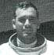
THE SLOW FLIGHT HOME
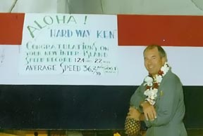
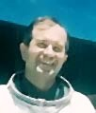
Memory of what happened with 131 on the way home varies depending on who you talk to. A-12 pilots Ken Collins and Frank Murray collaborated on getting Article 131 back from Kadena after the demise of OXCART. Murray remembers it being he who started off from Kadena with 131 enroute to a tanker down by Wake Island. Collins maintains that he flew that leg. Regardless, 131 developed a bad fuel leak and was recovered into Wake Island. Both agree that Ken flew the next leg after repairs at Wake, this on to Hickam, flying low and slow with the tanker in formation. The photo of Collins was taken when he arrived at Hickam after this leg, Then he left for home and Jack Week's Memorial service. Murray stayed with 131 and tried three times to get it to fly to the Area. The first two tries were aborted due to fuel leaks, they finally got it fixed and he did fly high and fast to the Area. The final recovery of 131 took eleven days from start at Kadena till Murray landed it back home at Area 51. Two days later, Murray flew 131 to Palmdale and parked it at the storage hangar with the assembled families watching the happenings. A sad moment for all as it was the last time the A-12 ever flew.

SUPER CRUISE By. Dennis Sullivan
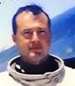
Near the end of the program I was scheduled for a North Vietnam photo mission from Okinawa. The weather briefing was marginal for photography. I was told to keep the low frequency radio volume up as I would be half way down there when the next satellite photo came in and I might get a recall. I was between Hong Kong and the Philippines when the radio came on with the coded recall message. I made a 180 turn and headed back to Okinawa. I had lots of fuel and knew that this was my last mission, so I came out of afterburner and left the throttles at military power to let the airplane slowly decelerate. To my surprise, the A-12 stabilized at about 2.7 mach around 68,000 feet without afterburner and maintained it all the way back to Okinawa, which I overflew and made a circle decent. I reported this at the debriefing and the comment was: "This was never tested, but should have". It could have extended the ferry range quite a lot. An amazing performance by a great airplane.
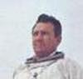
THE LAKE MEAD PARASAIL ADVENTURE
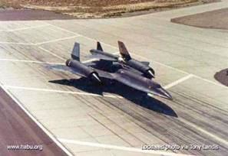
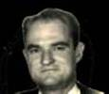
During a flight test on 30 July 1966 of the second A-12 to be converted to an M-21 for launching the D-21 reconnaissance drone the drone pitched down and struck the M-21, breaking it in half. Pilot Bill Park and LCO (Launch Control Officer) Ray Torick stayed with the plane a short time before ejecting over the Pacific Ocean. Both made safe ejection, but Ray Torick opened his helmet visor by mistake and drowned when his suit filled up with water. This terrible personal and professional loss drove Kelly Johnson to cancel the M-21/D-21 program. This accident also prompted water survival training by the A-12 pilots based at Groom Lake. Under the supervision of 1129th SAS commander Col. Hugh Slater, the pilots, wearing their flight suits, were lifted high above the waters of Lake Mead on a parasail being towed by the United States Coast Guard. The training was quickly aborted when some of the fully suited pilots almost drowned after dropping from the parasail into the water.
Charlie Trapp recalls: “Our rescue-survival section first tested the suits in the area pool adjacent to Sam’s Place. Casto jumped it out of our C-130 pressurized at high altitude, and during our parasail program at Lake Meade. We did a lot of things with our helicopters from construction, radar testing, and recovery of high value items dropped from the A-12. We ran a pistol range and survival training in Florida. Developed the walk-around sleeping bags. Helped make up the survival kits for the A-12, and a bunch of other stuff like flying support in the C-180, U3B, C-210, H43, UH1F and the C-130. We also stood alert for all test flights with a fire bottle and firemen along with PJs with the H43 and UH1F. Also, they somehow found me to fly LATE night emergency flights to Burbank in the U3B and C-210. When Colonel Slater decided to conduct water survival evaluation and training for the A-12 pilots at Lake Mead, myself, Castro and Bailey set up the project with the U.S. Coast Guard assigned to Lake Mead. Col. Slater had the Coast Guard set up a secure area for the Oxcart projects pilots at Groom Lake to practice water survival in their flight suits. Arrangements were made for each of the pilots to betaken aloft on a parasail pulled by a Boston Whaler.”
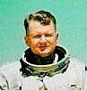
Col. Hugh “Slip” Slater recalls that he went first and didn't get any water in the suit. Dennis Sullivan went second and he too remained dry. After that the boondoggle went to hell due to high winds preventing the little Boston Whalers from keeping up. Layton's helmet filled with water, causing him to think he was still under water. Frank Murray kind of slithered off to one side while Layton floundered around with his helmet full of water, Mele had a hard time deflating the chute. At that point Slater cancelled the exercise.
From Frank Murray: Sad to say I was one of the poor guys that endured the Pressure Suit/parasail exhibition in Lake Mead in 1966 I think. I am not sure how many of the Project Pilots did the thing at the Lake. It is no easy trick to get airborne on the Parasail in a full pressure suit complete with survival kit and the parasail harness. On one attempt I was dragged onto the rocky shoreline, on another I was dragged through the water with a collapsed parasail, damn near drowned me. I was happy to see that effort done away with. It is like practicing getting hungry, like they do in the various survival schools I have attended over the years. I do remember that the Coast Guard furnished the boat used to get us up. I did get one successful launch and carry up to release altitude. After that I was not going to do that again. Nuf said, Frank
Ken Collins
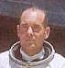
Jack Layton recalls: I was also one of the guys to endure the pressure suit parasail exhibition on Lake Mead in 1966. All went well until landing in the water at which time the face plate filled with water. I knew what was happening because I was expecting it since it had happened previously. One of the sergeants in the water assisted me into the boat and we all lived happily ever after.
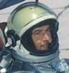
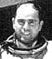
Dennis Sullivan recalls:I recall the parasail operation. I had my own boat and drove out to the bay where the parasailing was to take place. As I remember it, I believe I was the first to go. There was little or no wind and in the pressure suit, the boat pulled me off the beach and into the air with no problem. When they released the rope I floated down and released the chute when I hit the water. The boat was there immediately and I had no problems so they loaded me up and hauled me in. Mele went shortly after. He went up OK but the old chute we were using had the stitching come loose on one riser. When they released Mele he sort of spun in, hit the water pretty hard and darn near drowned before he finally came up. I think the rest if it went OK. About that time the wind came up and the boat trip back in was pretty rough.
Mele Vojvodich:

Who the heck was KILROY??
KILROY WAS HERE!
In 1946 the American Transit Association, through its radio program, "Speak to America," sponsored a nationwide contest to find the REAL Kilroy, offering a prize of a real trolley car to the person who could prove himself to be the genuine article. Almost 40 men stepped forward to make that claim, but only James Kilroy from Halifax, Massachusetts had evidence of his identity.
Kilroy was a 46-year old shipyard worker during the war. He worked as a checker at the Fore River Shipyard in Quincy. His job was to go around and check on the number of rivets completed. Riveters were on piecework and got paid by the rivet. Kilroy would count a block of rivets and put a check mark in semi-waxed lumber chalk, so the rivets wouldn't be counted twice. When Kilroy went off duty, the riveters would erase the mark. Later on, an off-shift inspector would come through and count the rivets a second time, resulting in double pay for the riveters. One day Kilroy's boss called him into his office. The foreman was upset about all the wages being paid to riveters, and asked him to investigate. It was then that he realized what had been going on. The tight spaces he had to crawl in to check the rivets didn't lend themselves to lugging around a paint can and brush, so Kilroy decided to stick with the waxy chalk. He continued to put his checkmark on each job he inspected, but added KILROY WAS HERE in king-sized letters next to the check, and eventually added the sketch of the chap with the long nose peering over the fence and that became part of the Kilroy message. Once he did that, the riveters stopped trying to wipe away his marks. Ordinarily the rivets and chalk marks would have been covered up with paint. With war on, however, ships were leaving the Quincy Yard so fast that there wasn't time to paint them. As a result, Kilroy's inspection "trademark" was seen by thousands of servicemen who boarded the troopships the yard produced. His message apparently rang a bell with the servicemen, because they picked it up and spread it all over Europe and the South Pacific. Before the war's end, "Kilroy" had been here, there, and everywhere on the long haul to Berlin and Tokyo. To the unfortunate troops outbound in those ships, however, he was a complete mystery; all they knew for sure was that some jerk named Kilroy had "been there first." As a joke, U.S. servicemen began placing the graffiti wherever they landed, claiming it was already there when they arrived. Kilroy became the U.S. super-GI who had always "already been" wherever GIs went. It became a challenge to place the logo in the most unlikely places imaginable (it is said to be atop Mt. Everest, the Statue of Liberty, the underside of the Arch De Triumphe, and even scrawled in the dust on the moon.) And as the war went on, the legend grew. Underwater demolition teams routinely sneaked ashore on Japanese-held islands in the Pacific to map the terrain for the coming invasions by U.S. troops (and thus, presumably, were the first GI's there). On one occasion, however, they reported seeing enemy troops painting over the Kilroy logo! In 1945, an outhouse was built for the exclusive use of Roosevelt, Stalin, and Churchill at the Potsdam conference. The first person inside was Stalin, who emerged and asked his aide (in Russian), "Who is Kilroy?" .. To help prove his authenticity in 1946, James Kilroy brought along officials from the shipyard and some of the riveters. He won the trolley car, which he gave it to his nine children as a Christmas gift and set it up as a playhouse in the Kilroy front yard in Halifax, Massachusetts. So now You Know!
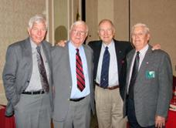
We didn’t get a story with this photo but it’s good to see and hear from Bob Gilliland and Andy Meyer all the way from Austin (that’s in Tejas) where they attended a Daedalian Luncheon. They’re lucky that there’s not enough space on this page for us to fabricate a story to go with the photo.

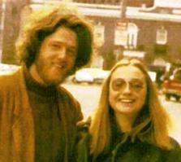
Only in America can one see in the same photo a husband and wife both having aspirations of being the commander-in-chief of the military forces of the United States. The dude made it – will the chick? Peace, Bro!!

THE CREW CHIEF
Credit goes to both RI Members James Bard and Mike Schmitz who provided this remembrance of our crew chiefs whom we all salute for jobs well done.
“The pilot was everyone's hero He was brave, he was bold, he was grand As he stood by his battered airplane With his goggles and helmet in hand But for each of these flying heroes There were thousands little renowned And these the men who worked on the planes But kept their feet on the ground We all know the name of Lindberg And we've read of his flight of fame But think if you can of his maintenance man Can you remember his name? And think of the wartime heroes And the acclaim that they all got Can you tell me the names of their Crew Chiefs? A thousand to one you cannot Now pilots are highly trained people And wings are not easily won But without the work of the maintenance men Our pilots would march with a gun So when you see a powerful airplane As it makes its way through the air Remember the grease stained man With the wrench in his hand For he is the one who put it there.”
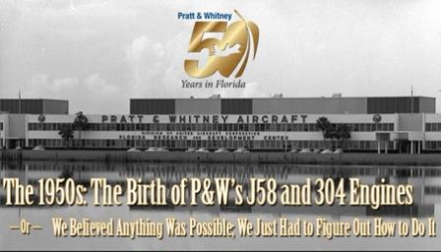
HAPPY BIRTHDAY PRATT & WHITNEY
Thanks to Bill Gent and Bob Davenport, we’ve posted the story and some “must see” photos on the web site at:

http://www.roadrunnersinternationale.com/pratt_whitney.html

Our quote of the month:
“Our scientific theory is that the rings of Saturn are composed entirely of lost airline baggage.”

The Roadrunners Internationale staff wishes to thank all the members and others who contributed to this newsletter. If we post something in error, we would like to know. We depend on you to help us get it right.
TIRED OF THE SAME FACES EACH EDITION? - SEND US YOUR STORIES AND GOSSIP.
President  T.D. Barnes | Vice President  Harry Martin | Secretary  Roger Andersen | Treasurer  Jim Prucnal | Historian  Frank Murray

