
ROADRUNNERS INTERNATIONALE MONTHLY HOUSE SIX NEWS AND GOSSIP
(Not to be confused with the Stars and Stripes)
1 May 2007 – 7th Edition

We are happy and relieved to report that none of our members deployed for boarding their final flight during the month of April. Way to go, troops!!!!!
Chairman, Harry Martin reports the Roadrunner Reunion schedule and events have changed slightly and can be viewed on the Member Activities page of the web site.
ROADRUNNERS INTERNATIONALE REUNION # 20
The nominating committee, consisting of Denny Sullivan, Ken Collins, Frank Murray, Bill Fox, and Russ Buyse, is asking if any Roadrunners would like to serve as one of the four elected officers from October 2007 to October 2009. The offices that need to be filled are President, Executive Vice-President, Secretary, and Treasurer. The election will take place at the business meeting as part of our October 2007 reunion. Although any Roadrunner can be an officer (no Associate Members can hold an elected position), much of the work that goes on between reunions occurs in Las Vegas. As a result, living outside of the LV area can be a hardship on the team. The current slate of officers, TD Barnes, Harry Martin, Roger Andersen, and Jim Prucnal are willing to serve another term.

If you are interested in serving as an officer, please email TD Barnes at tdbarnes@area51specialprojects.com, stating the office you wish to be considered for.

Thank you. Looking forward to seeing a big turnout at Reunion 20.

Russ Buyse

MEMBERSHIP DUES RENEWAL
For the 2d month in a row, some of you upgraded your membership dues to permanent membership after the last newsletter. We thank you. As an important reminder to those whose 2-year membership expires this year, membership dues must be paid current prior to arrival at the reunion. The staff officers will be engaged in reunion affairs; therefore the hospitality desk will be manned by volunteers. All member financial matters must be resolved prior to arrival for the reunion. We will continue reminding you

Kudos to Russ Buyse, Tom Bolich, Tom Stanks, and Wayne Nelson who now have their bios posted on the RI Wall of Fame.
ROADRUNNER EXHIBIT AT THE ATOMIC MUSEUM
We’re still looking for Aquatone, Oxcart and Blackshield era photos of all you Roadrunners for the Roadrunner exhibit at the Atomic Museum during the reunion.

Thanks to those responding to our request for the affiliation of all our members. We need it not only to establish the Roadrunner legacy, but to also credit our members for their continuing contributions to the aviation community. Roadrunner Dino Brugioni is a good example. Dino was one of the founding fathers of the National Photographic Interpretation Center. He was involved in helping plan the U-2, Oxcart and SR-71 and satellite missions, including his being responsible for preparing the briefing boards and notes used to brief the President, the Congress, and high ranking officials. He has written 5 books, among them Eyeball to Eyeball, rated the best book on the Cuban Missile Crisis. He has also written about 100 articles on reconnaissance and interpretation and has helped with and appeared on over 80 television programs dealing with reconnaissance and interpretation. Dino has received numerous awards for his work, the latest being inducted into the National Geospatial Intelligence Hall of Fame. “You do us proud, Dino”
Another excellent example is Hal Rupard, the first Blue Suiter assigned to the Tagboard Project. Hal was assigned to Area 51 in July 1965 as an understudy to Lockheed engineers Keith Beswick and Ray Torrick in preparation for operational D-21 launches as flight testing concluded.




Our thanks to Joe Donoghue who noticed that the A-12 manuals have finally surfaced on the CIA FOIA READING ROOM site.
http://www.foia.cia.gov/default.asp
Search for "a-12" (without the quotes) will produce a list of 62 documents. Included is the 459 page dash-1 and the other manuals he forwarded to some of us last year.
Additionally, there are over 800 pages of "A-12 Flight Logs" which appear to consist of post-flight cables. Some interesting stuff in there. Also, there are PI reports on several OX missions including:
BX6847 (The first Pueblo mission) 132 pages
BX6732 71 pages
BX6740 49 pages
BX6725 79 pages
BX6723 96 pages
BX6705 47 pages
x-003 (third mission before they settled on the BXyynn format) 45 pages x-001 30 pages, and several documents regarding the loss of Article 125.
* * * * *
EDWARDS AFB –By the end of summer, visitors to Edwards Air Force Base will have a new attraction telling the story of the world's premier flight test center, one available to all. The Century Circle will feature six "Century Series" fighters: F-100, F-101, F-102, F-104, F-105 and F-106. These aircraft, some which have not been on display before, will be grouped around the top portion of the base's old control tower, used in the testing heydey of the 1950s and 1960s. Unlike the Air Force Flight Test Center Museum with which it is affiliated, the exhibit will be outside the base gates, allowing unrestricted access to the general public. It is on Rosamond Boulevard, adjacent the public tours parking lot just west of the West Gate guard house. The display will benefit not only the visiting public, but also those who work on base. Most of the aircraft for the display are ready, with the F-100 heading for the paint hangar in a couple weeks, said museum director Doug Nelson. For details, contact the Air Force Flight Test Center Museum at (661) 277-8050.
* * * * *
Blackbird Airpark. The Blackbird Airpark will be getting YF-117A # 79-10783 this summer and it will be displayed at the airpark. The AF troops at the 410th TS are working the demil now and will help restore for display. All the other Stealth Fighters will be flown to Tonopah for long-term storage so the Blackbird Airpark-along with Nellis and the AF Museum(and probably Holloman)-will be the only displayers of the F-117.
* * * * *
Hamilton Books, a remainder house in Connecticut, is selling the 2004 edition of Paul Crickmore's Lockheed Blackbird: Beyond the Secret Missions. 400 pages "Fully revised and updated”. Newly declassified information. More "color" photographs." Original price was $39.95 but Hamilton has an unknown number of copies for sale at $12.95. Even those who have an earlier edition might find this an attractive price for an up-dated version. There is much information and many illustrations which were not in previous editions. The website is: http://www.hamiltonbook.com and the ordering info for the Blackbird book is on this page: http://www.hamiltonbook.com/hamiltonbook.storefront/4623b6f10003a8a3271d424d 36d6064e/UserTemplate/7 Postage and handling is $3.90 for one book. Postage for 3 books is $4.95 (to CA).
* * * * *

MAINTAINING OUR ROADRUNNER/MILITARY LIAISON
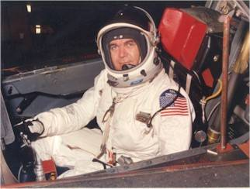
Some of our SR-71 members have asked their fellow Roadrunner members to support a memorial for General O’Malley. A SR-71 Model dedication is scheduled for Veterans’ Day, November 11th, 2007 in Carbondale, PA. James Crossley, former U-2 Pilot, is donating this 8 foot, 300 pound model of the SR-71 and smaller models of all aircraft General O’Malley flew. Final Memorial Dedication is scheduled for May 29th, 2008 in Carbondale, consisting of a flyover and an Air Force band. General John Jumper, Former Air Force Chief of Staff, will be the honorary speaker. The dedication will be attended by family, high school friends, West Point classmates, the SR-71 Community, Air Force, Army, Navy, and Marine military friends and organizations, corporate sponsors, and local, state and federal officials. General O’Malley’s career was a most distinguished one, having attained 4 star rank and serving as Commander of the most coveted position in the Air Force for pilots, the Tactical Air Command, a command consisting of up to 115,000 personnel, including the Air Force Thunderbirds. General O’Malley was destined to be the Air Force Chief of Staff or Chairman of the Joint Chiefs of Staff at the time of his death on April 20th, 1985. Tragically, his career and life was cut short that day as he and his wife, Diane, died together in a plane crash at the Wilkes-Barre/Scranton, Pa. airport. A web page for this project has been established at: http://area51specialprojects.com/OMalley/General_OMalley.htm. Those wishing to contribute to the O’Malley Memorial should contact Tony Bevacqua at tonysru2@comcast.net
* * * * *
Beale needs a Child Development Center (CDC), which is a 24 hour baby-sitting/school operation with all the required Ps and Qs. This present one is 40 years old with lead in some painted areas, asbestos, and poor plumbing. 150 children max allowed. Last month, 9 of us went to D.C. to hit the “Hill” and talk with some congressmen and senators and/or their staff, to ask them for a Congressional Insert, because that would be the only way Beale would get any funding for it even though it was approved for milcon, and their #1 priority the last four years, and it still is. The new one we are asking for will hold 305 kids, so you see it is not excessive since it will immediately fill up. (There is a waiting list of over 170, and who knows how many more there could be because some don’t get on the list knowing they don’t have a chance.) Senator McCain sits on the Appropriations Committee, so we are looking for help on asking him to get this insert approved. He, like any other Senator/Congressman, won’t listen/talk to out-of-state people, so I am asking your help in contacting him to ask him for that help. An example of our proposed letter can be downloaded at: Download Letter. We also are asking for your help on other AZ residents who may possibly have his ear that we can ask to do this. If so, please let me know. We really feel that this is more than a Quality of Life issue. Knowing our mission, we have been at a war time ops tempo since 1989! It is mission essential IMHO. Your help will be greatly appreciated. Thank you very much. Tony Bevacqua (Chairman of BMLC)
* * * * *
LAS VEGAS—RI president T.D. Barnes represented the Roadrunners at a groundbreaking that took place Monday, 23 April at Nellis Air Force Base, just north of Las Vegas, Nevada. The ceremony initiated construction on what will be the largest solar photovoltaic (PV) array in the United States, capable of producing 15-18 megawatts of power. At least for a year or so, say Air Force officials, the plant will also constitute the largest such facility in the world, encompassing an investment of $100 million on 140 acres.
* * * * *
A-12 Happenings
When the A-12 future became an issue in Washington in 1967, the decision was made to conduct a fly-off between the A-12 and SR-71. The general ground rules were to fly the same route from the West Coast across the Northern US to the Great Lakes, then Southeast to Florida (re-fueling from central Georgia to St. Petersburg) and then back to the West Coast via New Orleans, Dallas, Albuquerque, etal. The mission "take" from both aircraft would be analyzed by an independent group of intelligence experts. The winner would take all. Both aircraft would have to complete the mission on the same day or a re-fly would be scheduled. The first two attempts resulted in an air abort or sensor failure by The A-12 on one day and the SR-71 on the other. On the third attempt, both aircraft completed the mission successfully. Denny Sullivan flew the A-12...Al Pennington and I flew the SR-71. The entire Northern US was covered by clouds that day and the A-12 take was of no intelligence value in that first half of the mission. At least we had SLR and ELINT products to offer. When the weather cleared, both aircraft had good imagery and luckily, our cameras worked like a charm. The SR-71 was declared the winner. In June 1969, I moved to Edwards as the SR-71/YF-12A JTF Ops Officer and later become the JTF Director when Joe Rogers was transferred to Viet Nam. Slip Slater was the ADC chief and Jack Layton joined us in 1970. I did fly both airplanes. I checked out Don Mallick and Fitz Fulton in the YF-12A when NASA joined the program. Mele Vojvodich and I car pooled while assigned to the Pentagon in 1980-82. William Campbell Dutch 70
* * * * *
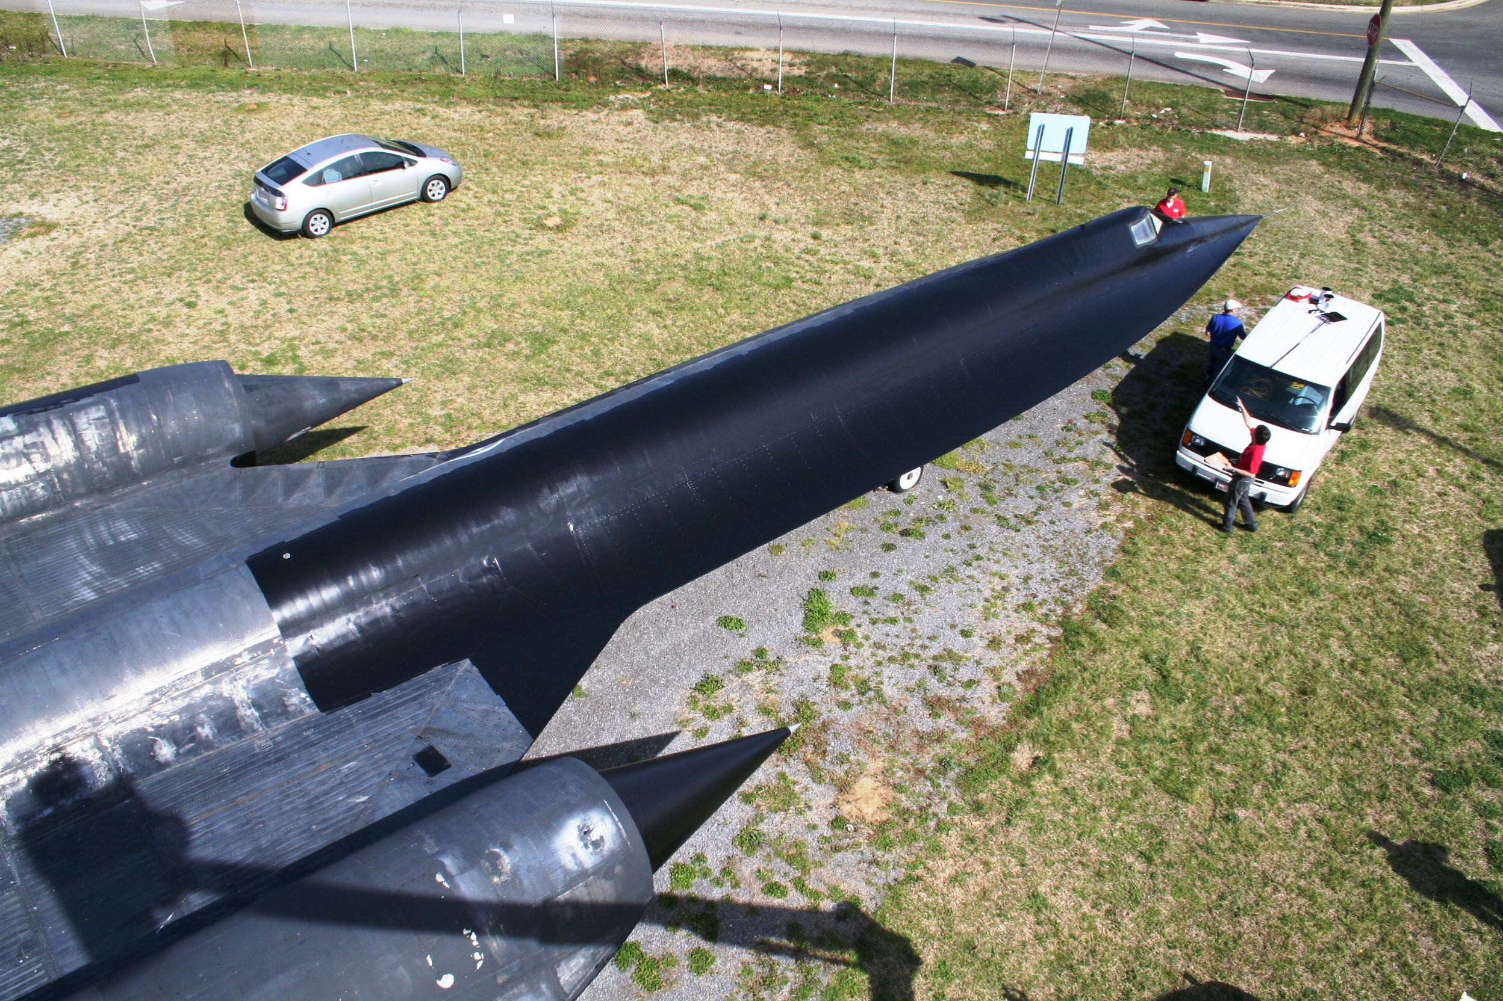
Jim Griffin, Director of the Southern Museum of Flight has requested assistance from the Roadrunners in acquiring instruments for the cockpit of Article 131 (60-6937). A qualified crew has been assembled to repaint the plane and replace its decals. Director Griffin took over the Southern Museum of Flight about 18 months ago and reports about 65,000 visitors a year to view its 26 outdoor aircraft and another 40 aircraft indoors. Article 128 being mounted on pylons at CIA Headquarters won’t need instruments, so if the instruments stolen from that plane can be recovered, perhaps they could be used to restore Article 131 that is viewed at ground level.
* * * * *
Last Saturday the SR-71 at Beale was moved from the flight line up to the cantonment area IN ONE PIECE, with absolutely no problem. The Heritage Park that was started now has its first aircraft in place. Beale AFB is hoping to get all the planes that were stationed at the base to complete the display.
* * * * *
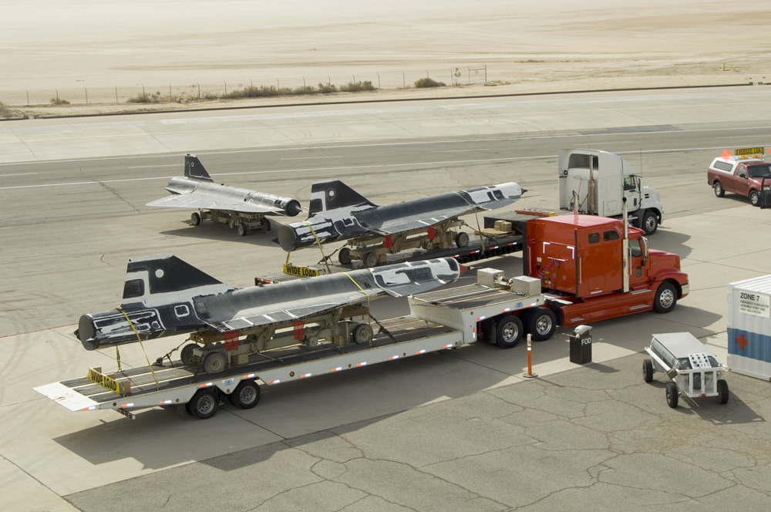
Tony Landis reports that 2 of the NASA D-21's headed back to AMARC. D-21's 522 and 529 had their chines removed and were loaded onto separate trucks for the trip back to the boneyard. The third D-21, 537 has been allocated to the March AFB museum. According to AMARC, Dryden was given four drones, 513, 525, 529 and 537. 525 were transferred to the Blackbird airpark some time back. When the engines were removed from the other three, it was found that we actually had 522 and not 513 as the paperwork stated.
* * * * *
DO YOU REMEMBER?
By: Sam Pizzo
This one is for you mature, and by now somewhat elderly early bird arrivals at Groom Lake at the end of 1961. Do you remember the early Monday mornings hopping in your car taking the leisurely two hour ride to the area, watching vehicles scream past you when you were doing 80 mph or better? And then you got to do it in reverse come Friday afternoon. How about that great mess hall about the size of a shoe box where it was commonplace to see guys standing up eating as there was not enough room for everyone to be seated. And then we had a great outstanding sport complex which came down to a cement tennis court. Great fun in the middle of July and August .Did we have a bowling alley? Can't recall. And wasn't it great sitting around the radio late in the evening listening to maybe one station you could pick up. Mountains sure have a negative impact on radio listening during daylight hours! Then again weren’t the television programs we watched just great. Course this was only in your dreams. As for thrills, you could get into Charlie Trapp's chopper and go chasing mountain lions down a mountain flying at tree top level (sage brush, scrub pine bushes etc). Perhaps you found it more enjoyable to go with Gil Saunders in his C 130 and go chasing wild horses on the Utah Flats, coming up on a herd you were flying so low that you looking up the horses rear ends ! And how about the runway sweeps, before we got a sweeper, getting the small rocks cleaned off before the A-12 took off. Those pebbles sure played havoc with the turbine blades resulting in some engine changes. And that leads into the next tidbit of history which follows.
In the future years some historian may find oyster shells scattered around an abandoned old airbase (was it CIA or Air Force or whatever) and comes up with a multitude of answers as to how oysters found their way to the desert area of the country. The truth of the matters lies with Gil Saunders C-130, broken A-12 engines, GE engine repair facility located near the old Westover AFB and a friendly Club Officer at that base. How and who got it started, I do not know, but somehow an arrangement was made whereby a list was started as to who wished what kind of seafood to be picked up at Westover when a flight was scheduled. A call was made to this nice Club Officer, the day before the flight, who then in turn picked up the seafood, placed it in the frig and when Gil made it to Westover, he picked up the goodies. At times the good folks in the new mess hall put their culinary skills to work and such goodies as Lobsters, Oysters and Scallops were munched on. One of the bright spots at the Ranch as far as living conditions was concerned, was the building of the new mess hall and staffing it with outstanding cooks. If anyone left the Ranch after four years and didn't gain a few pounds, they were on one heck of a diet.


RI Officer Staff Meeting 4-17-2007
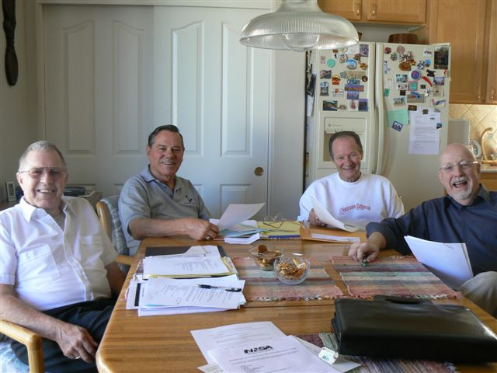
TD Barnes Harry Martin Jim Prucnal Roger Andersen Frank Murray AWOL
President  T.D. Barnes | Vice President  Harry Martin | Secretary  Roger Andersen | Treasurer  Jim Prucnal | Historian  Frank Murray
Keep sending us your stories and comments to share with the other members.

