
ROADRUNNERS INTERNATIONALE MONTHLY HOUSE SIX NEWS AND GOSSIP
(Not to be confused with the Stars and Stripes)

1 November 2007 – 13th Edition

FINAL FLIGHT
10 October 2007 Dewayne “Pete” Franzen
REUNION UPDATE:
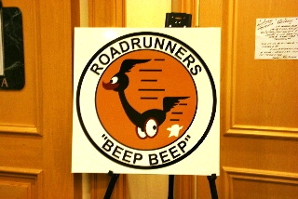
The torch has been extinguished for the 20th Reunion of Roadrunners Internationale. The reunion was such a success that a new torch has already been lit for the 21st Reunion to be held 5-9 October 2009 at the Gold Coast Hotel and Casino. Mucho kudos to our RI Executive Vice President Harry Martin and his committee for a job well done. Godspeed Harry as out Reunion Chairman for the 21st RI Reunion in 2009. Rumor has it that “Harry for President - 2009” bumper stickers are being printed as we speak.
20th BIENNIAL MEMBERSHIP MEETING
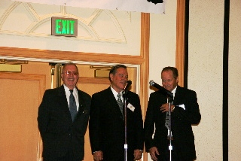
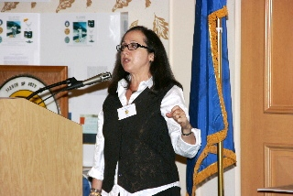
The morning of the 3rd day of the reunion started out with the outgoing officers of RI bribing the membership with free coffee and doughnuts. With full stomachs and the nerves of the Roadrunner members settled by an overdose of caffeine, RI president T.D. Barnes kicked off the meeting with a heartfelt honor of our nation’s flag with most of the former military members rendering the hand salute as recently allowed by US Congress. Minutes of the 19th meeting were presented by RI Secretary Roger Andersen followed with a financial report by Treasurer Jim Prucnal. Russ Buyse chairing the election committee for the election of officers raised the hopes of the outgoing officers’ being replaced as he rambled on about how hard the membership committee worked to come up with new officers. This was obvious by big grins, thumbs up gestures and even a couple hi-fives at the officers’ table. These hopes were slowly dashed as the old officers realized Russ was uttering BS and that the coffee and doughnuts bribes weren’t working. There were no new officers waiting in the wings, so the old staff became the newly elected slate of officers. T.D. Barnes – President, Harry Martin – Vice President, Roger Andersen – Secretary, Jim Prucnal – Treasurer, and Frank Murray – Historian. The next go around the bribes will be doughnuts and whiskey. The effects of coffee were obviously grossly overstated and poorly researched. Following the election, Dr. Mary Palevsky PhD, Director of the UNLV Nevada Test Site Oral History Project gave a talk to the membership about the need to get our Cold War stories documented as part of Cold War history. As Dr. Palevsky pointed out, the Roadrunner history has a priority as it was all done under the cloak of secrecy and has never before been told or documented.

Roadrunner Financial Matters
Now having most of the reunion expenses paid, the reunion committee can safely say that the event will about breakeven and maybe even show a small profit. This was possible in part because of the Roadrunners who donated nearly $600 into the Roadrunner exhibit fund from which the staff paid the material costs for the posters covering the walls of the Command Post to depict photos and bio information about our members during the early U-2, A-12 and YF-12 programs. This exhibit will carry over to our next reunion, however we wish to duplicate and improve it for mobile use at various RI occasions other than the biennial reunion. Anyone wishing to donate into the Roadrunner Exhibit Fund can do so by contacting any of the RI officers. All money received will be forwarded to our treasurer.
More about the reunion by T.D. Barnes
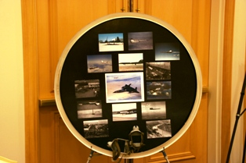
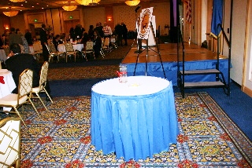
For a while it was feared that the attendance was going to be below the minimum we had anticipated during the setting up phase of the reunion. Several of those usually attending had to send their regrets that they couldn’t make it this year. We want you to know you were missed. We set up a missing member table for those who couldn’t be with us. Our members rallied at the last minute with members attending from Canada, Australia, and several from the UK, bringing our attendance for the banquet to 232. The Command Post layout this year was focused on recognizing the individual member for his or her contribution to the U-2 Aquatone and A-12 OXCART programs. The walls were lined with photos and brief bios of individual members. Various maintenance manuals of the various planes and drones were displayed as well. Frank Murray’s updated Roadrunner scrapbook was a major attraction as always. Frank had also prepared a great photo display inside the ring of a J-58 engine which he mounted on an easel. Both the Linegroup and the CIA EAA store had displays of merchandise for sale, which added to the tempo between scheduled events. Through the Herculean efforts of Harry Martin, the tour of the Nevada Test Site was by all accounts a great event. Unlike the reunion 2 years ago, none of the buses broke down or got lost. Wonder how Harry managed that?? Let’s sign him up to organize the tours at the next reunion.
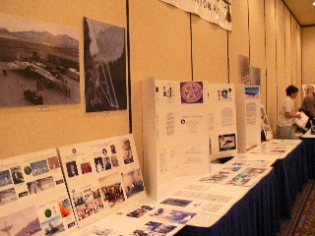
We’re sure most of you noted that unlike the last reunion there were no long lines at the registration table or members waiting around for the RI treasurer to show up to conduct financial business. However, in spite of our numerous messages to the members this past year asking them to take care of their dues and registration prior to arriving at the reunion, 15 members showed up as “walk-in’s” and expected the treasurer to give up his time with family and friends to conduct business that we had informed everyone we would not do. Those folks owe Jim and Judy Prucnal big time for serving the walk-ins in addition to their other duties for the occasion. It’s a miracle that we still have a treasurer. They also owe the reunion chairman, the hotel catering department, and their fellow members who had to scramble for seating and food that hadn’t been previously arranged for. In addition to our owning thanks to Jim and Judy for making themselves available every day, we also owe thanks to the volunteers who sacrificed their time to work behind the scenes and at the reception desk to make the reunion a pleasant success. Chalk up another successful golf tournament for Roger and Slip who fielded a total of 15 golfers. We didn’t hear much bragging about scores or handicaps, except from Rosemarie who won the honors of best everything in the ladies category. Way to go, Rosemarie!!!! We owe a lot of thanks to Chris Pocock and Pete Merlin for their excellent presentations the afternoon of the third day. The topics this year were all related to Groom Lake, so obviously they were of interest to the Roadrunner members. Chris and Pete put a lot of effort and expense into their presentations for which the Roadrunners attending were very appreciative. By the way, Rosemarie – weren’t you the only lady golfer in the tournament?
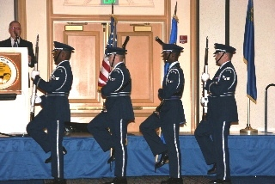
There is no longer any doubt as to the prowess and cunning of our VP/reunion organizer. This was demonstrated just before the banquet when only one bar was being manned. The line was extremely long with thirsty Roadrunners getting increasingly impatient when Harry arrived at the back of the long line to investigate. He took one look and let out a commanding whistle that quickly summoned a bartender to open the second bar. In a rigid about-face maneuver that would have made an OCS instructor proud, Harry took command, barked a couple about-face commands to reverse the back half of the original line and marched toward the second bar with Ron Girard and the rear half the original long line in tow. With total lack of guilty conscience he headed the line, ordering him and his lovely wife, Mary each a drink before nonchalantly strolling off, leaving those shocked souls who were in the middle of the first line now at the far end on the second line and those at the end of the first line now at the head of the second line. Harry, hate to put you on the spot, but are you sure you weren’t an LC?
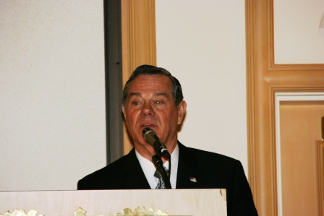
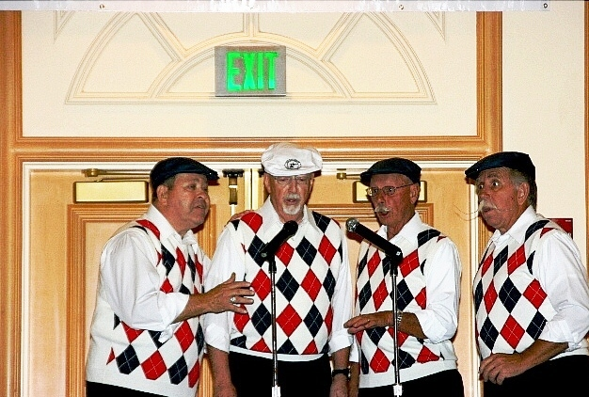
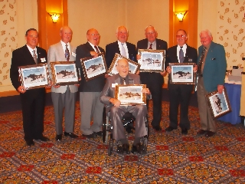
The Roadrunner reunion this year was organized more for relaxation. We tried to keep all the scheduled events optional as well as flexible. Roger Andersen was the MC and did a great job as always. We had no guest speaker to bore everyone with a Power Point presentation explaining the TO&E of a Predator wing or the specs on the latest smart bomb. The Nellis AFB Honor Guard performed the flag ceremonies followed by everyone chowing down in a well-organized fashion ramrodded by Jim and Judy Prucnal. No lost seating chart this year???? BORING!!!!! Photos were taken at each table before the occupants headed for the food line. Alan Johnson and Mike Schmidt did an excellent job taking the photos again this year. Joerg Arnu received credit from Barnes for the photos taken by Alan. He didn’t refuse or correct the credit, so obviously he learned something from our VP’s booze line tactics. Hmmm. Too bad associates can’t hold office. Joerg has obviously learned the secret to successful leadership. Joerg does deserve credit for running the video and audio equipment during the banquet. For entertainment, we were honored with an excellent performance by Roger Andersen’s barbershop quartette, the Rah Rah Rumble Seats, followed by the four project pilots, the past RI presidents, and current officers each being presented with a photo of the A-12 autographed in 2002 by the 5 project pilots. The framed photos were provided by Mike Schmidt. Sincere thanks to you Mike from all of us. On a somber note, it was very touching to watch Jack Layton being pushed to the stage by his fellow A-12 pilots. This reminded some of us that only a week earlier TD Barnes was being pushed through the Dulles and McCarran air terminals by Harry Martin, and only a few months ago it was TD Barnes and Roger Andersen doing the same for Frank Murray during a trip to California and back. We were honored to have as guests at the banquet Dr. Mary Palevsky from UNLV, Marie McMillian - the most awarded lady aviator in the United States, the Nellis AFB Honor Guard, Cheryl and Barbara from the CIA, and the wives and children of many of the Roadrunners. George Knapp and Matt of KLAS TV provided excellent coverage of the reunion on the local prime time news.
MEMBERS & UPGRADES
August 2007 we had 72 temporary 2-year members
The RI Staff of officers is pleased to inform the membership that most of the 72 members facing expiration of their membership on 1 September upgraded from temporary to permanent membership. Twenty-eight of the temporary members failed to renew their dues and have been dropped from our membership rolls. We did all we could to retain them as members in good standing, including personal letters and e-mail messages. At this point our association has 286 permanent members and 12 2-year temporary members. Chasing our 2-year members for their dues renewals has consumed more time than anything else, including the organizing of the reunion. Not knowing every two years if the members planned to renew their membership has made it difficult to plan events and budget for upcoming reunions. This was well documented this past reunion when two months prior to the reunion we didn’t know how many of the 72 2-year members would renew and attend our functions. As you can see, almost 10% of our membership did opt to drop out of our association, causing a last minute scramble by the reunion committee to adjust our contract with the host hotel to escape financial penalties for failure to achieve planned attendance. Now having only 12 members in the temporary category, this will not be a major factor as we budget for the next reunion. Whoever was responsible for convincing our two-year members to upgrade to permanent membership should consider a job recruiting for the U.S. Army.
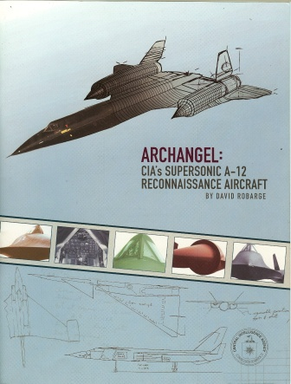
CIA HAPPENING
CIA Chief Historian, Dr. David Robarge deserves a lifetime of kudos for the excellent job he did to record our Roadrunner legacy in the book he authored entitled ARCHANGEL: CIA’s Supersonic A-12 Reconnaissance Aircraft. Dr. Robarge has posted the Archangel book on the Agency's public web site at
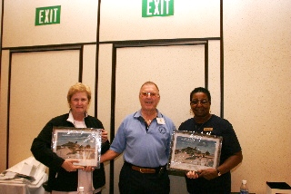
https://www.cia.gov/library/center-for-the-study-of-intelligence/csi-publications/books-and-monographs/a-12/index.html Those of you who did not obtain a copy at the reunion can do so by contacting TD Barnes who reports that we have a few copies left over from the reunion. Details are posted at the bottom of this newsletter. It’s a tossup who enjoyed their attending our reunion the most, the Roadrunners or Cheryl and Barbara with the Agency’s EAA store. We’ll see you two in two years along with the rest of our newly found friends at the Agency who couldn’t make it this go around.

A-12 NEWS
Article 132 - Alabama Battleship Memorial Park By: Frank Murray
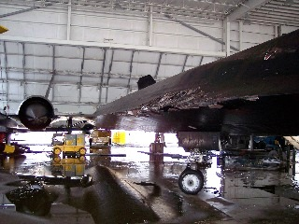
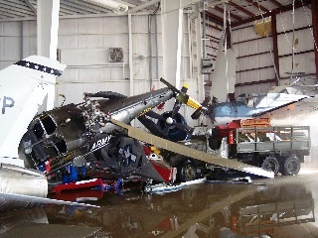
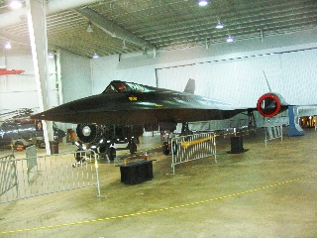
Mike Thompson, Curator of the A-12 Article 132 at the Battleship Alabama Museum gave me an update on Article 132 that was heavily damaged by the Hurricane last year. He told me he pretty much has it fixed again, thanks in part to parts and materials he got from Mike Relja at NASA. He did get a new spike among lots of other pieces. Some of the damaged titanium panels couldn't be copied in that metal so he substituted with aluminum, which when painted looks good enough. He did say he got an almost new J-58 engine (SR version w/variable first stage guide vanes) with less than an hour of ground run since overhaul in 1989. Four airplanes in the Museum were damaged beyond repair, and the F-4U Corsair was so heavily damaged that he gave it to the Carrier Midway in San Diego where there is Navy talent to help fix the F-4U. He said he has a continuing challenge from people who think 132 is an SR-71. Apparently a good many people don't know about the A-12. Mike’s mailing address is: USS Alabama Battleship Memorial Park, P.O. Box 65, Mobile, AL 36601.
Article 128 – CIA McLean
Though we Roadrunners consider each of the A-12s in retirement to be “Our Plane,” many of us will probably remain a bit partial here out to Article 128 because of the Roadrunners’ role in rescuing the plane and getting it into the capable hands of CIA Museum Director, Toni Hiley. We thank the CIA and the Air Force folks, General Metcalf, Air Force Museum Director Terry Aikens, OSI, et al at Wright Patterson for letting the Roadrunners participate in the rescue and the dedication ceremony during the Agency’s 60th Anniversary. You made us feel that we still have the “Right Stuff.”
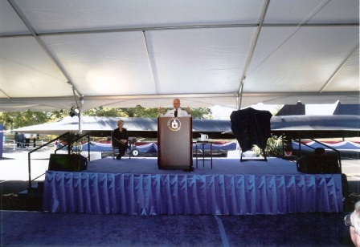 | 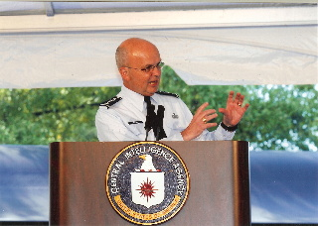
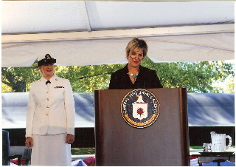 | 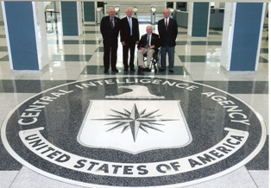

Congratulations to our Habu brother, Pat Bledsoe, who is being inducted to the Arkansas Aviation Hall of fame on November 15th at 6:00-9:00 PM, Aerospace Education Center (IMAX Theater) 3301 East Roosevelt Road, Little Rock, Arkansas.

REUNION PHOTOS, ARCHANGEL BOOK, FUTURE NEWSLETTERS, & “STUFF”
Thanks to Mike Schmitz, Alan Johnson, Nolan, and others we have a ton of photos taken at the reunion that we will be happy to make available digitally to the members via CD. Production and mailing costs will be $5 per mailing. Included will be the Article 128 dedication photos provided by the Agency. Because of privacy concerns as many were wearing nametags, we have agreed to not post the CIA photos for public viewing without approval of the agency. We trust that our members will also honor this agreement. Contact TD Barnes at 468 Palegold St., Henderson, NV 89012 if you want to order the reunion photo CD and/or the Archangel book. The photo CD and book can be combined for those wanting both. Combined production and shipping costs will be: $7.50.

As you will note at the top of this newsletter, this is the 13th edition. Each month the newsletter is published by E-mail to those members and others on the mailing list. Only on special occasions has a copy been mailed by USPS because of the costs of mailing. If any of you wish to be placed on a USPS mailing list at the cost of production and mailing, please let T.D. know. Normal monthly costs will probably average $2 per mailing, or $24/year. That doesn’t sound like much $$ if you say it fast. Try multiplying it by 262 members and it’s another matter. The Roadrunner volunteers helping with the monthly printing, correlation, folding, mailing labels, envelope stuffing, stamping and mailing gets a free copy along with beer, peanuts, and a lot good laughs. Harry, the rest of us have already bought a supply of those bumper stickers.

AND DON’T FORGET THAT WE NEED YOUR GOOD GOSSIP TO PUT IN THE HOUSE SIX NEWSLETTERS.

Planning ahead for the reunion, it will help us if you members will let us know what you did and didn’t like about the past one. Please think about it and let us know what you would like to do at the next reunion.

Anyone wanting to be removed from the electronic and/or USPS mailing list should also let T.D. know. Those dropping out will give the rest of us something to talk about.
HOUSE SIX STORIES
Sorry! This month’s stories didn’t pass censorship in time for posting.
TIRED OF THE SAME FACES EACH EDITION - SEND US SOME STORIES AND GOSSIP.
President  T.D. Barnes | Vice President  Harry Martin | Secretary  Roger Andersen | Treasurer  Jim Prucnal | Historian  Frank Murray

